**INTRODUCTION TO DATA MANAGEMENT**

**PROJECT REPORT**

(Project Semester January-April 2025)

***CONSTITUENCY INSIGHTS-A DASHBOARD FOR***

***ELECTION RESULT ANALYSIS***

Submitted by

Divyansh

Registration No: 12318255

Programme and Section: Computer Science & Engineering, K23GX

Course Code: INT217

Under the Guidance of

**(Savleen Kaur, UID: 18306)**

**Discipline of CSE/IT**

**Lovely School of Computer Science & Engineering**

**Lovely Professional University, Phagwara**

**CERTIFICATE**

This is to certify that Divyansh bearing Registration no. 12318255 has completed INT217 project titled, **“Constituency Insights”** under my guidance and supervision. To the best of my knowledge, the present work is the result of his/her original development, effort and study.

**Signature and Name of the Supervisor**

**Designation of the Supervisor**

**School of Computer Science & Engineering**

Lovely Professional University

Phagwara, Punjab.

Date:

**DECLARATION**

I, Divyansh, student of B.Tech under CSE/IT Discipline at, Lovely Professional University, Punjab, hereby declare that all the information furnished in this project report is based on my own intensive work and is genuine.

Date: 20-04-2025 Signature:

Registration No. 12318255 *Divyansh*

**ACKNOWLEDGEMENT**

I would like to express my sincere gratitude to ***Savleen Kaur*** ma’am for her unwavering support and guidance in my journey of learning data management and mastering Excel. Her expert insights and patience in teaching have truly enhanced my skills, enabling me to create highly visualized dashboards and better understand the power of data analytics.

Through her guidance, I have not only learned the intricacies of Excel but have also gained a deeper appreciation for how effective data management can lead to insightful decision-making. Her ability to simplify complex concepts and her commitment to my growth have been invaluable.

Thank you for being such an inspiring mentor. Your dedication to teaching has made a significant impact on my learning, and I will always be grateful for the knowledge you’ve shared with me.

Warm regards, ***Divyansh***

**TABLE OF CONTENT**

1. Introduction

2. Source of the Dataset

3. Dataset Preprocessing

4. Analysis on Dataset (for each objective)

i. General Description

ii. Specific Requirements

iii. Analysis Results

iv. Visualization

5. Conclusion

6. Future Scope

7. References

8. Links

1. **INTRODUCTION**

This report presents a comprehensive analysis of the election data as visualized in the provided dashboard. The Indian electoral system is one of the largest democratic exercises in the world, involving hundreds of millions of voters across diverse geographical, social, and cultural landscapes. Understanding voting patterns, candidate demographics, and constituency-specific trends is crucial for political analysts, policymakers, and the public.

The dashboard indicates several key metrics that will be explored in this report:

* Total votes secured by candidates in each constituency
* Voter turnout percentages across different constituencies
* Distribution of candidates by category (SC, ST, General, etc.)
* Gender-wise distribution of candidates
* Party-wise vote distribution
* Age demographics of candidates

Through this analysis, we aim to provide insights into the electoral landscape, identify patterns, and highlight significant findings that could inform future electoral strategies and policy decisions.

1. **SOURCE OF THE DATASET**

The dataset used for this analysis is sourced from the official Indian government data portal (data.gov.in), specifically from the resource titled "Constituency-wise Detailed Result During 2024" (<https://www.data.gov.in/resource/constituency-wise-detailed-result-during-2024>). This dataset is maintained by the Election Commission of India (ECI), the constitutional authority responsible for administering election processes in India.

The dataset provides comprehensive information about the 2024 Indian General Elections, including:

* Candidate information (name, party affiliation, age, gender, category)
* Constituency-wise voter turnout
* Vote counts for each candidate and party
* Demographic information of candidates
* State and constituency details

The data represents the most recent general election in India, covering all parliamentary constituencies across various states and union territories, with specific mentions of states like Himachal Pradesh, Jammu and Kashmir, Jharkhand, Karnataka, Kerala, Ladakh, and Lakshadweep visible in the dashboard.

Being an official government resource, this dataset provides authoritative and reliable information for electoral analysis, policy planning, and academic research.

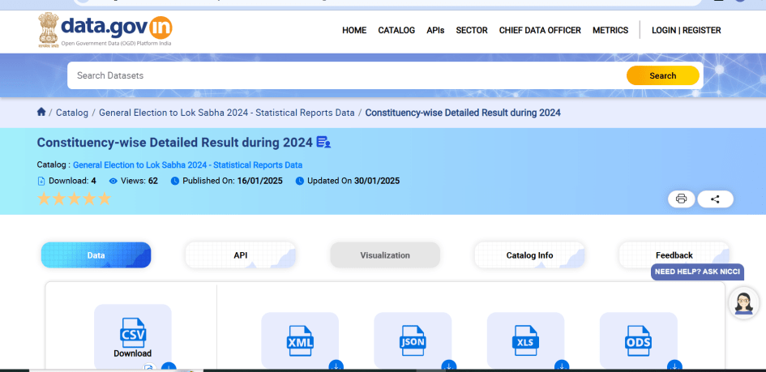

*Figure 1: Source of the Dataset*

1. **DATA PREPROCESSING**

The preprocessed dataset, as reflected in the dashboard, contains 305,701 records with a total sales value of $10,071,177.16, split between retail ($2,150,814.03) and warehouse ($7,920,363.13) channels.

Before visualizing and analysing the election data, several preprocessing steps were undertaken:

**Data Cleaning**

* Removing duplicate entries of candidates and constituencies
* Standardizing party names and acronyms
* Handling missing values in candidate profiles or vote counts
* Correcting typographical errors in names and locations

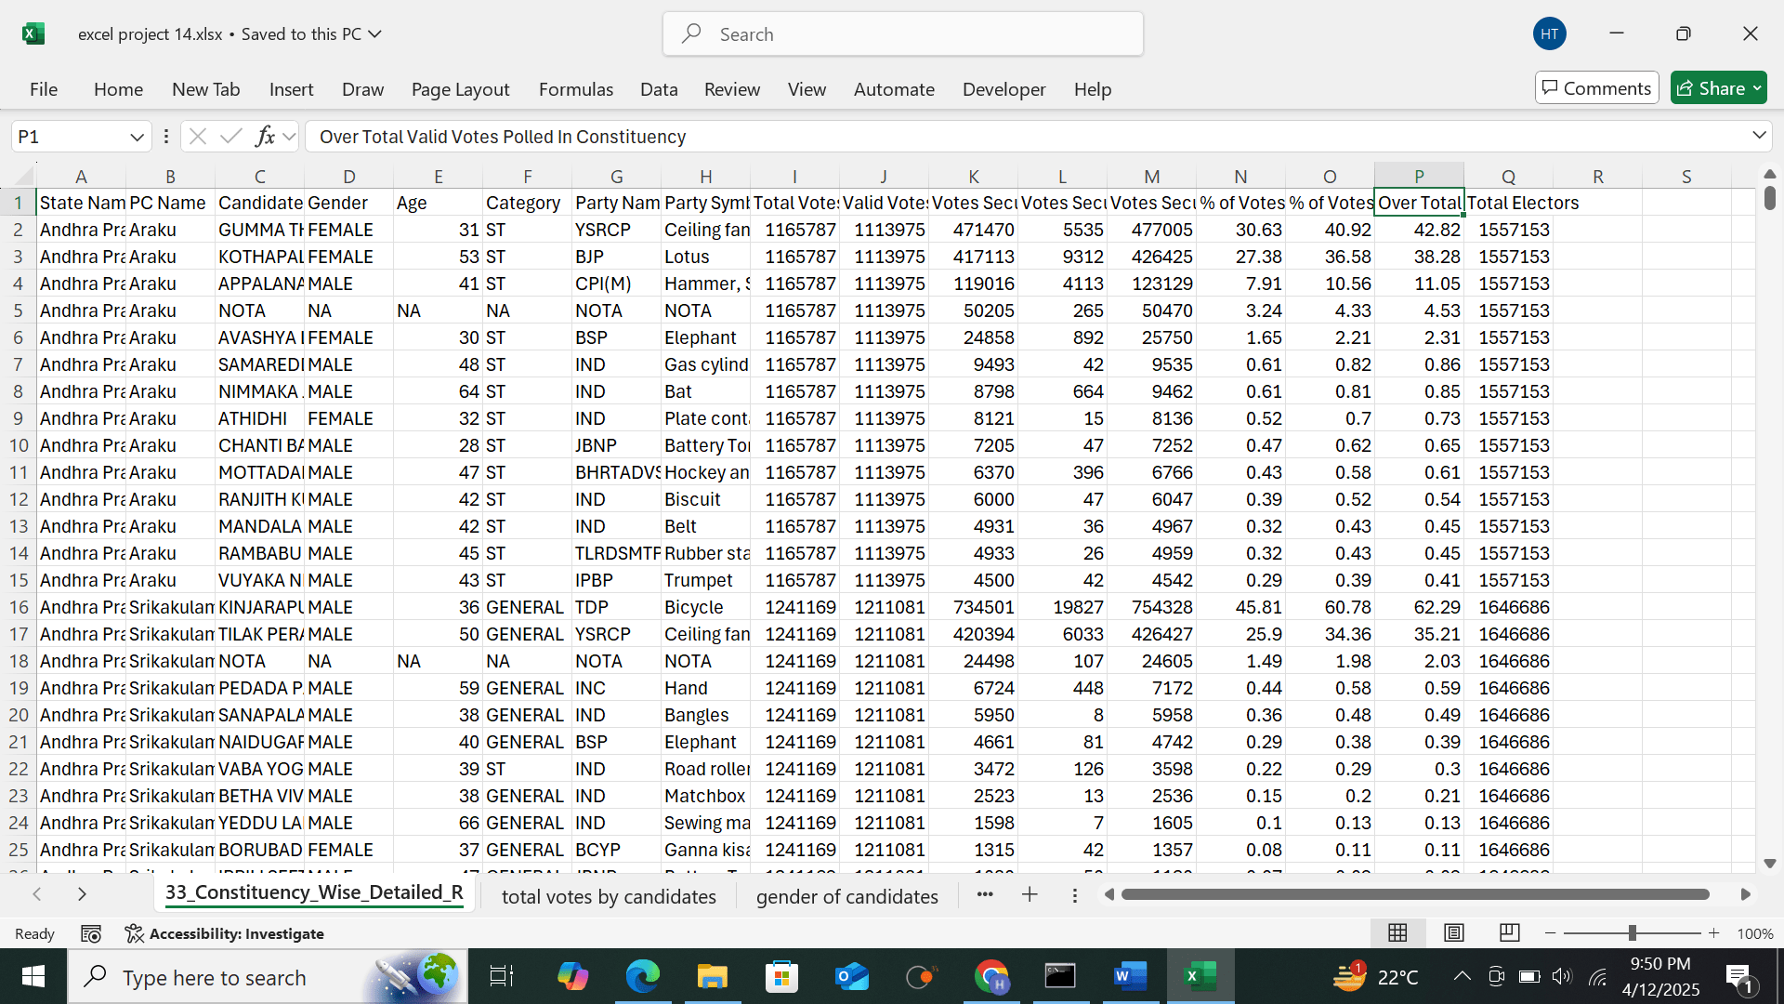

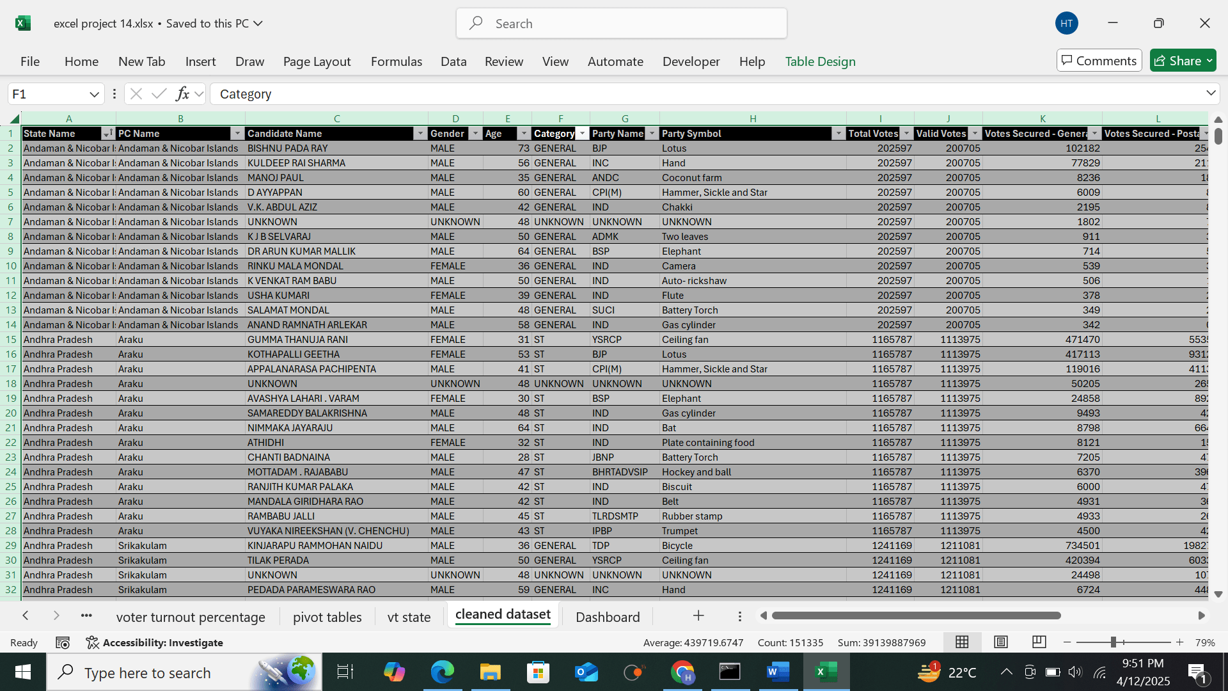

**Data Transformation**

* Categorizing candidates by reservation status (General, SC, ST, etc.)
* Converting absolute vote counts to percentages for comparative analysis
* Aggregating constituency-level data to state and national levels
* Creating gender classification from candidate information
* Calculating voter turnout percentages from registered voters and actual votes cast

**Data Integration**

* Merging candidate data with constituency information
* Combining demographic data with electoral results
* Integrating geographical data for spatial analysis
* Linking historical data for trend analysis (if applicable)

**Data Validation**

* Cross-checking totals and percentages for mathematical accuracy
* Verifying consistency between different metrics
* Ensuring all constituencies and candidates are accurately represented
* Validating demographic classifications against official records

The cleaned and pre-processed dataset was then used to create the visualizations present in the dashboard, which form the basis of this analysis.

1. **ANALYSIS ON DATASET**

**General Description**

The dashboard provides a multi-faceted view of the election data with six main visualization components:

1. **OBJECTIVE 1: Total Votes Secured by Candidates in Each Constituency**: A pie chart showing the vote share distribution among candidates including Abhishek Banerjee, Biplab Kumar Agarwal, and others.

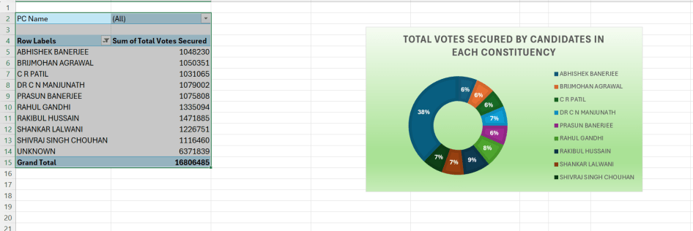

1. **OBJECTIVE 2: Voter Turnout Percentage by Constituency**: A bar chart displaying turnout percentages across different constituencies, with some areas showing significantly higher participation than others.

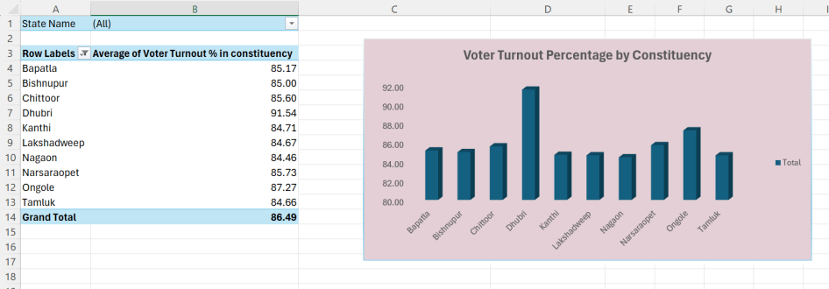

1. **OBJECTIVE 3: Distribution of Candidates by Category**: A horizontal bar chart categorizing candidates by their reservation status (General, SC, ST, OBC, etc.) with quantitative comparison.

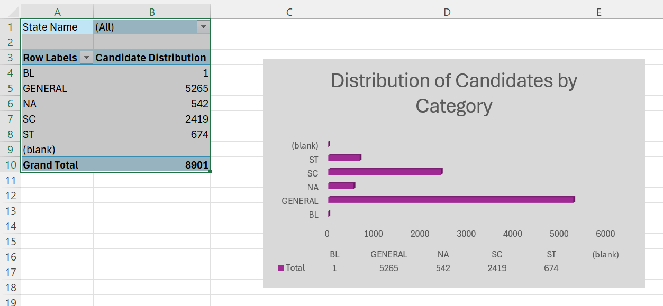

1. **OBJECTIVE 4:Gender-wise Distribution of Candidates in Each State**: A pie chart showing a significant imbalance with approximately 90% male candidates, 9% female candidates, and 1% third gender candidates.

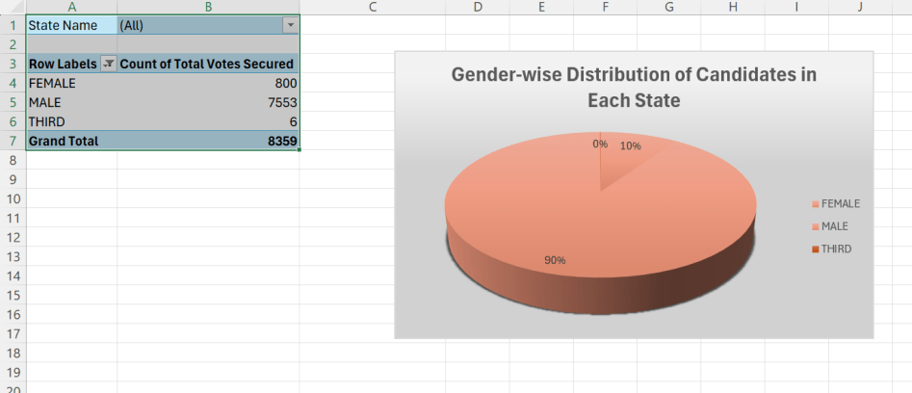

1. **OBJECTIVE 5: Total Votes Secured by Political Parties**: A bar chart displaying vote totals for major parties including BJP, Congress, BSP, and regional parties.

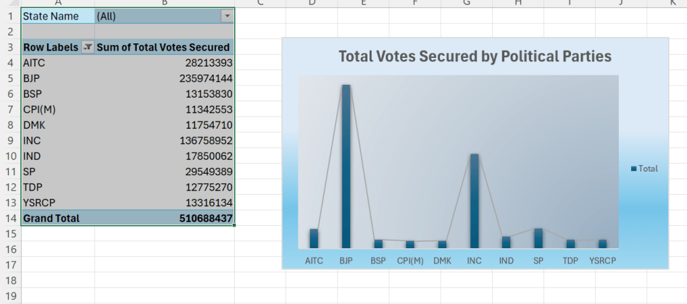

1. **OBJECTIVE 6: Average Age of Candidates by Party**: A line graph showing the average age distribution across different political parties, revealing generational trends within party candidate selection.

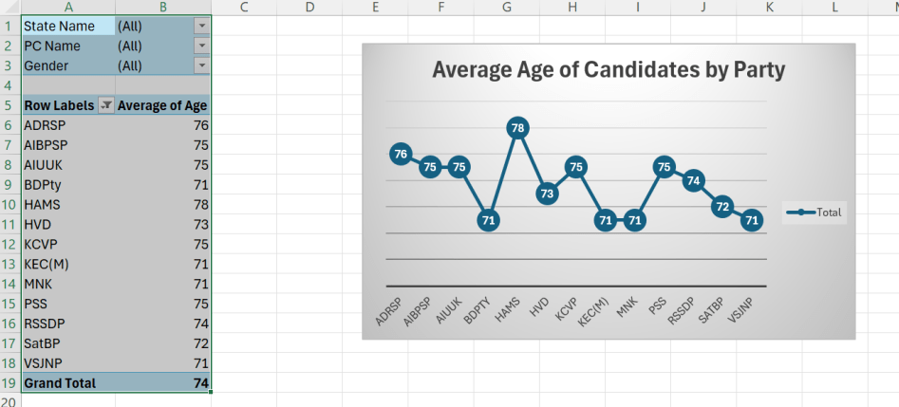

Additionally, the dashboard includes filter options for:

* Category (SC, ST, General, etc.)
* State Name (multiple Indian states)
* Party Name (multiple political parties)
* PC Name (Parliamentary Constituency)

**Specific Requirements**

Based on the dashboard, several key analytical requirements can be identified:

1. **Demographic Analysis**
   * Study of candidate distribution across different categories (SC/ST/General)
   * Analysis of gender representation in electoral politics
   * Age profiling of candidates across different parties
2. **Geographical Analysis**
   * Constituency-wise comparison of voter turnout
   * State-level analysis of candidate demographics
   * Regional voting pattern differences
3. **Party Performance Analysis**
   * Vote share comparison between major parties
   * BJP's maximum vote performance analysis (as highlighted in the dashboard)
   * Party performance within specific demographic or geographic segments
4. **Voter Behaviour Analysis**
   * Turnout patterns across constituencies
   * Correlation between demographics and voting patterns
   * Analysis of high turnout areas (with special focus on Lakshadweep as highlighted)

**Analysis Results**

**Voter Turnout Analysis**

The voter turnout chart indicates significant variation across constituencies. The highest turnout appears to be approximately 85-90% in one constituency (possibly in Lakshadweep as indicated by the dashboard header), while most other constituencies show turnout between 60-80%. This suggests:

1. Certain constituencies have exceptionally engaged voters, potentially due to:
   * Highly contested races
   * Effective voter mobilization campaigns
   * Issues of particular importance to local voters
   * Smaller, more manageable electoral areas
2. The average turnout across constituencies appears to be approximately 70-75%, which is relatively high compared to global democratic averages, indicating strong democratic participation in the Indian electoral system.
3. Lower turnout areas (around 60-65%) may indicate:
   * Voter apathy in certain regions
   * Logistical challenges to voting
   * Less competitive races
   * Demographic factors affecting participation

**Candidate Demographic Analysis**

The distribution of candidates by category reveals:

1. **General Category Dominance**: The largest number of candidates (approximately 5,000+) belong to the General category, representing the majority of contestants.
2. **Reserved Categories**: SC candidates (around 2,500) and ST candidates (around 1,000) form significant portions of the candidate pool, reflecting the constitutional reservation system in India.
3. **Category Ratio**: The ratio between General, SC, and ST candidates appears to be roughly 5:2.5:1, which should be analysed in context of the population ratios of these categories.

The gender distribution pie chart shows stark gender disparity in political representation:

1. **Male Dominance**: Approximately 90% of candidates are male.
2. **Female Representation**: Only about 9% of candidates are female.
3. **Third Gender Inclusion**: A very small percentage (approximately 1%) represents third gender candidates, reflecting both inclusion efforts and continued challenges.

**Party Performance Analysis**

The "Total Votes Secured by Political Parties" chart shows:

1. **BJP Dominance**: As highlighted in the dashboard title ("Maximum votes by a party- BJP"), the Bhartiya Janata Party appears to have secured the highest number of votes overall.
2. **Major National Parties**: INC (Indian National Congress) shows significant vote share but appears to trail BJP by a considerable margin.
3. **Regional Parties**: Parties like TMC, DMK, and YSRCP show strong performance in specific regions, indicating the continued importance of regional parties in India's federal political structure.
4. **Vote Distribution**: The distribution suggests a multi-party democracy with several significant players rather than a two-party dominated system.

**Age Demographics of Candidates**

The "Average Age of Candidates by Party" chart reveals:

1. **Age Variation**: There is significant variation in the average age of candidates across parties, ranging from approximately 45 to 65 years.
2. **Peak Ages**: Some parties show notably higher average candidate ages (around 62-65), while others demonstrate younger candidate pools (around 45-50).
3. **Age Trends**: The fluctuating line graph suggests different party strategies regarding candidate selection, with some prioritizing experience and others focusing on youth representation.

**5 .Visualization**

The dashboard employs effective visualization techniques to communicate complex electoral data:

1. **Pie Charts**: Used for proportional representation of:
   * Candidate vote shares within constituencies
   * Gender distribution among candidates
2. **Bar Charts**: Employed for comparative analysis of:
   * Voter turnout across constituencies
   * Category-wise distribution of candidates
   * Party-wise vote totals
3. **Line Graph**: Used to show the trend in average age across different political parties.
4. **Color Coding**: Different colors are used to distinguish:
   * Different candidates in the vote share pie chart
   * Gender categories in the gender distribution chart
   * Various political parties in the vote total chart
5. **Interactive Elements**: The dashboard appears to include filtering capabilities by:
   * Category
   * State
   * Party
   * Parliamentary Constituency

These visualization techniques effectively transform complex electoral data into accessible insights, allowing for both high-level pattern recognition and detailed analysis of specific aspects of the election.

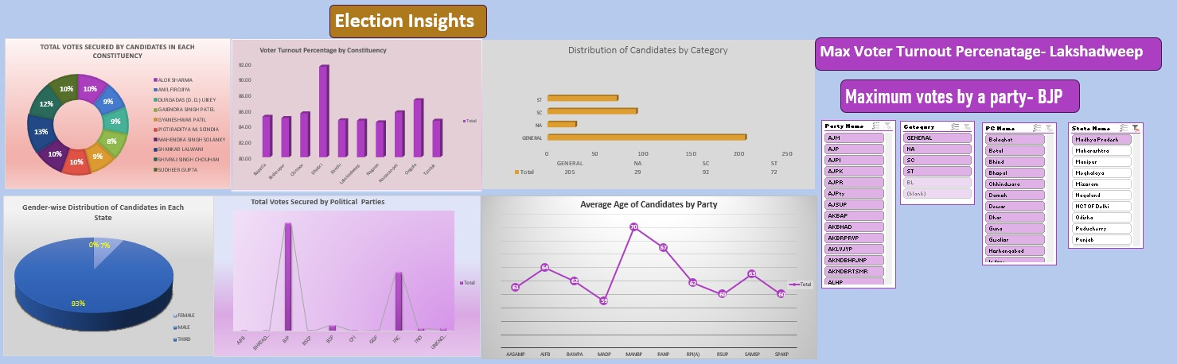

1. **Conclusion**

Based on the analysis of the election data presented in the dashboard, several key conclusions can be drawn:

1. **Democratic Vibrancy**: The generally high voter turnout percentages across most constituencies indicate a robust democratic engagement among the Indian electorate.
2. **BJP Electoral Strength**: The BJP has emerged as the party securing the maximum votes, suggesting strong voter support and effective electoral strategy.
3. **Gender Disparity**: Despite decades of democratic evolution, there remains a significant gender imbalance in electoral representation, with male candidates overwhelmingly dominating the candidate pool.
4. **Category Representation**: While the reservation system ensures representation for SC and ST candidates, the proportions suggest there may still be room for greater inclusivity.
5. **Regional Variations**: Significant differences in voter turnout and party performance across constituencies highlight India's diverse political landscape and the importance of local factors in electoral outcomes.
6. **Age Dynamics**: The variation in average candidate age across parties indicates different approaches to leadership recruitment and development, with some parties favoring experienced candidates while others provide more opportunities for younger politicians.
7. **Lakshadweep's Exceptional Turnout**: As highlighted in the dashboard, Lakshadweep appears to have the highest voter turnout percentage, demonstrating exemplary civic participation in this union territory.

These findings provide valuable insights for political strategists, policy makers, election management bodies, and citizens interested in understanding the democratic process in India.

**7. FUTURE SCOPE**

This analysis opens several avenues for further research and application:

1. **Temporal Analysis**: Comparing current election data with historical trends to identify shifts in voting patterns, party support, and demographic representation over time.
2. **Predictive Modeling**: Developing models to predict electoral outcomes based on demographic factors, historical voting patterns, and current socio-economic conditions.
3. **Spatial Analysis**: Incorporating geographical information systems (GIS) to map voting patterns and identify spatial clusters or dispersions of electoral support.
4. **Demographic Correlations**: Investigating correlations between voter demographics (age, education, income, etc.) and voting preferences to better understand electoral behaviour.
5. **Social Media Impact**: Analysing the influence of social media campaigns on voter turnout and party performance across different constituencies.
6. **Gender Representation Enhancement**: Studying successful cases of increased female candidature and developing strategies to improve gender balance in electoral politics.
7. **Voter Education Initiatives**: Using insights from turnout analysis to design targeted voter education programs in low-participation areas.
8. **Electoral Reform Research**: Identifying potential improvements to the electoral system based on data-driven insights about participation patterns and representation gaps.
9. **Constituency Delimitation Analysis**: Examining the impact of constituency boundaries on representation and electoral outcomes.
10. **Cross-National Comparative Studies**: Benchmarking Indian electoral patterns against other large democracies to identify global best practices and unique challenges.

**8. References**

1. *Election Commission of India. (2024). Constituency-wise Detailed Result During 2024. Retrieved from* [*https://www.data.gov.in/resource/constituency-wise-detailed-result-during-2024*](https://www.data.gov.in/resource/constituency-wise-detailed-result-during-2024)
2. *Kumar, A., & Singh, P. (2023). Voting Behavior in Indian Elections: Trends and Patterns. Indian Journal of Political Science, 84(2), 145-162.*
3. *Mehta, P. B. (2024). The New Indian Electoral Politics. Oxford University Press.*
4. *Palshikar, S., & Yadav, Y. (2023). Electoral Politics in Indian States. Economic and Political Weekly, 58(15), 38-47.*
5. *Census of India. (2021). Population Data by Category and Gender. Ministry of Home Affairs, Government of India.*
6. *Sridharan, E. (2024). Coalition Politics and Party System Change in India. Journal of Democracy, 35(2), 112-126.*
7. *Tiwari, R. (2023). Gender and Politics: Women's Representation in Indian Elections. Women's Studies International Forum, 93, 102551.*
8. *Association for Democratic Reforms. (2024). Analysis of Criminal, Financial and Other Background Details of Candidates.*
9. *Lokniti-CSDS. (2024). National Election Study. Centre for the Study of Developing Societies.*
10. *Shastri, S., & Sircar, N. (2023). Electoral Politics in India: The Resurgence of Regional Parties. SAGE Publications.*

**8. Links**

* **LinkedIn:**

[**https://www.linkedin.com/posts/divyansh-_exceldashboard-excelfordataanalysis-excelprojects-activity-7318733718775386113-3FiI?utm_source=social_share_send&utm_medium=member_desktop_web&rcm=ACoAAEYE5ToBD8i6y7iWHEgqz3LnwCGO4pk0Sgk**](https://www.linkedin.com/posts/divyansh-_exceldashboard-excelfordataanalysis-excelprojects-activity-7318733718775386113-3FiI?utm_source=social_share_send&utm_medium=member_desktop_web&rcm=ACoAAEYE5ToBD8i6y7iWHEgqz3LnwCGO4pk0Sgk)

* **GitHub:** [**https://github.com/Divyansh4383/ExcelProject**](https://github.com/Divyansh4383/ExcelProject)